Cherry Valley Nursery & Landscape Supply (951) 845-5626 * (951) 845-7045
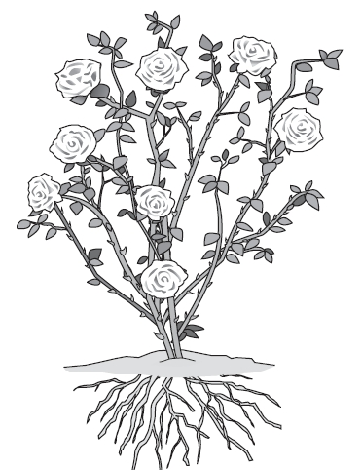
There is no warranty, returns or replacement on bareroot or any other plant material!
Rose Care
Roses have a reputation for being difficult to care for, but with the correct amount of water and sunlight and a little bit of grooming, your roses should thrive. Explore these basics of caring for your roses — but if you forget or muff something, the plants are surprisingly forgiving:

- Spacing: Allow ample space between plants for good air movement. This cuts down on diseases.
- Irrigation: The rule of thumb is to give moisture slowly at low volume. Deep soakings are much better than frequent, shallow waterings. Set the hose at the dripline of the rose and let water trickle in. Or if you have a big bed of roses or roses and companions, use a soaker hose or install an in-ground system. It is best NOT to water roses overhead or at night.
- Mulching: A layer of good organic mulch serves to discourage weeds, cool soil conserve water and encourage earthworms.
- Fertilizing roses: During Dormancy: Apply Sul Po Mag & Alfalfa Meal during this period, to help promote larger healthier blooms & growth. (Do not fertilize new plants until growth is 4-6 inches long and then, only at half strength.) Starting in Spring: You can use EB Stone Rose & Flower fertilizer, because it has proper amounts of N (nitrogen), P (phosphorus), and K (potassium), specifically blended for roses. As the plant emerges from dormancy, you can also water with two tablespoons of Epsom salt (magnesium sulfate) dissolved in a gallon of hot water (let cool) to promote strong canes & brighter blooms. Always water before applying fertilizer so the plant is plumped up and under no stress.
- Grooming roses: Using sharp clippers, you can spruce up your rosebushes whenever something unattractive about the plant catches your critical eye. Here's what you can cut out any time you see it:
- Dead wood: Remove dead canes down to the ground level.
- Damaged wood: Cut back within 1 inch of healthy wood.
- Misplaced stems: Take off stems that are rubbing together (choose one and spare the other), stems that are taking off in the wrong direction, filling the center, and stems that are trailing on the ground.
- Suckers: On a grafted plant, these errant canes emerge from below the bud graft union (the bulge at the base of the bush). The suckers look different from the rest of the bush — they're often smoother, straighter, lighter in color and very vigorous. Another clue: They sprout leaves and occasionally mongrel flowers that look nothing like the main bush.
- Deadheading and tidying up roses: Give the plant a general, balanced shaping. The plant looks better when you get rid of spent flowers. Also, because the goal of all flowering plants is to stop flowering and produce seed (in the case of rosebushes, to make rose hips), deadheading thwarts the process. So the plant is fooled into making more flowers. Deadhead away! Whenever you see badly damaged, diseased, or dead leaves, remove them. To be on the safe side, throw them in the trash rather than in the compost pile. Otherwise, the leaves may spread disease or bugs.
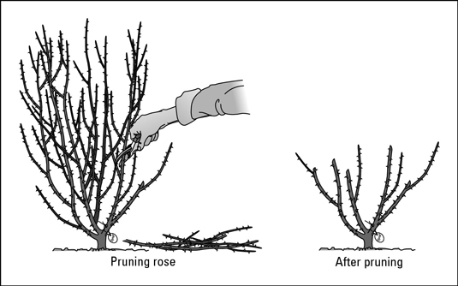
- Pruning roses: In Southern California the best time to prune is January. Pruning is pretty straightforward: Thin the plants, and then shape them. Experts advise cutting 1/4 inch above a bud eye so the bud eye doesn't dry out.

Use clean, sharp clippers, and cut at a 45-degree angle about ¼” above a bud. Cut near a bud eye, the tiny brownish or reddish bump on the stem (not to be confused with a thorn).

- Spraying roses: December/January is the best time to spray Copper Fungicide and All Season’s Mineral Oil. After cutting back your roses, Apply Copper and a week later All Seasons. As the new growth emerges it’s best to apply again, every 2-4 weeks. The more you prevent in the spring, the less problems you will see later on! Don’t spray when temperatures are over 85 degrees. In the summer, spray in the evening, when it’s cooler.

Cherry Valley Nursery & Landscape Supply (951) 845-5626 * (951) 845-7045
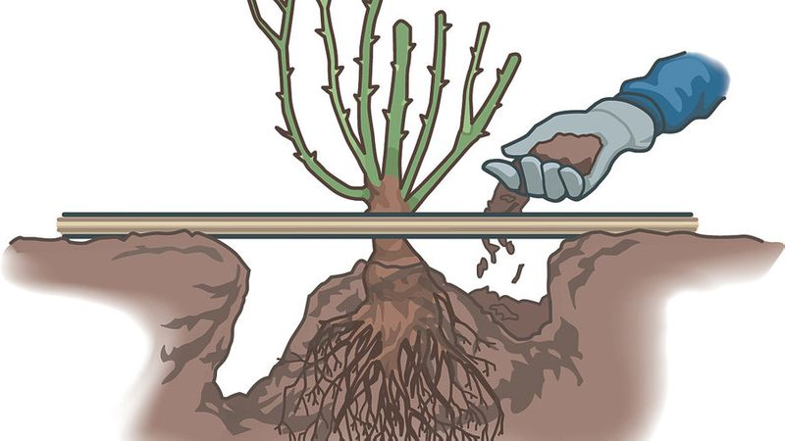
There is no warranty, returns or replacement on bareroot or any other plant material!

Follow these steps to plant your bareroot rose

Step 1: Use the right tools
For this job, you will need the following tools: a shovel, pruning shears, and a wheelbarrow or container for debris.

Step 2: Pick an appropriate spot to plant
Your rose bush will need at least 6 hours of sun each day, so choose a sunny spot to plant.

Step 3: Clean up plant
Use pruning shears to balance the length of the canes to the length of the longest root. This may seem to be a severe cut
Because there may be some damage to your bareroot rose, clip off some twigs and some tops of the canes, as well as some end of roots to promote new growth.

Step 4: Dig a hole big enough for the plant
Dig a hole that is wide enough and deep enough for the roots of your bareroot rose. Pile some dirt back into the hole to create a cone-shaped mound for the roots to rest on and spread the roots over this mound.

Step 5: Cover roots with soil
Cover the roots of the your bareroot rose with soil. For a grafted rose, you want the bud union to be right around soil level, but know that this does vary by zone. In zones 6-10, the bud union should be about 1" above the soil surface. In zones 5 and under, it's a good idea to bury the bud union about 1" under the soil. In our area, we are Sunset Zone 18 or USDA 9B.

Step 6: Water
Give your bareroot rose a large drink of water to settle the soil so that there is no air left around the roots.

Step 7: Optional: For Cold Weather Areas or Local Mountains - Mound soil around canes
Mound soil up to almost the top of the canes to protect the rose from drying out. When the shoots start to grow, pull the soil away from the plant so that rose bush is back at the proper level.
Step 8: Keep Canes misted to prevent die-out of canes
Lightly mist the canes with a water bottle or a hose end. Spray a few times every day or so, to keep moisture on the canes, until they start to grow. This is important in our dry climate.

