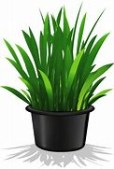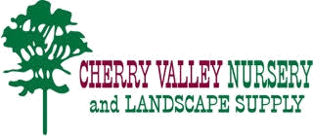

***PLEASE DON’T KILL ME!***

***The biggest challenges we see with plants when they go home, is improper watering and planting.***

***We DO NOT Warranty our plant material!***

Due to the fact that we pay for all of our plant material upfront (unlike box stores) we all work hard to keep them alive and healthy and we want you to do the same! Pay close attention to the leaves and quality of the plant. If you see some negative changes, email us a picture at [CherryValleyNursery@hotmail.com](mailto:CherryValleyNursery@hotmail.com).

***How To Plant & Prep The Hole***

Dig the hole approximately twice the diameter of the root ball and equal to its depth. Set the tree in the hole so the top of the rootball is even **or 1” higher** than the surrounding soil level. Add backfill soil, firming it as you go. **Water Thoroughly**!

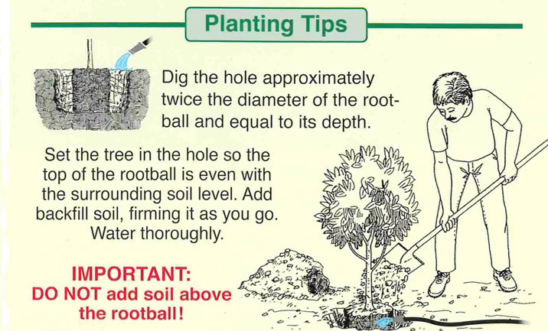

**Nothing on top of**

**rootball🡪**

***<--Notice the Hose***



***HOW DO I WATER MY PLANTS?***

First question - How Big is the root ball? Is this a 6pack, 4”, 1,5,or 15 Gallon or 24” Box? Smaller root systems will require more water, also rootballs with very little soil will dry out quicker as well.

***Not Planting Immediately?*** *They will need to be watered more often. We water ours daily in the heat, and depending on the plant and weather 6pks, and 4” could use it two times a day.*

* **Water in the Morning.** If you do get moisture on the leaves, this gives them time to dry out. It’s much more difficult for plant diseases to get a foothold when the foliage is dry.
* **Water deeply & thoroughly.** Lawns and annuals concentrate their roots in the top 6 inches of soil; for perennials and small shrubs 12-24 inches and larger shrubs & trees 3-6 feet below the surface. Use your soil Moisture sensor to check the progress.
* **Focus on the root zone.** Remember that it’s the roots that need access to water, not leaves. Wetting the foliage is a waste of water and can promote the spread of disease.
* **Water only when needed.** Automatic timers are especially useful; just make sure to watch the weather, and reduce frequency when rainfall is abundant. Too much water can be just as damaging to plants as too little.
* **Mulch everything.** Mulch reduces surface runoff and slows evaporation from the soil. Added bonus, it helps control weeds.