Cherry Valley Nursery & Landscape Supply (951) 845-5626 * (951) 845-7045
Fruit Tree Care
If you are new to home fruit growing, welcome and congratulations, you are already one step closer to picking tree-ripened, fully-flavored, healthy fruit from your own trees. You also might be about to begin a uniquely rewarding hobby. This guide is to help you with your initial setup of your new fruit trees and ongoing care.

Setup for planting your fruit tree
- Know your site's drainage.
Most fruit trees will not survive in soil that drains so slowly it remains saturated for extended periods. Before planting, be sure you are familiar with how well your soil drains.
Test your drainage.
- Dig a hole about 1 foot deep and fill it with water.
- If the water drains within 3 or 4 hours, fill the hole again.
- If it takes longer than 3 or 4 hours to drain on the 1st or 2nd filling, you could have problems!
If your site drains poorly your options are:
- Don't plant there.
- Plant the tree above the present soil line by constructing a berm, mound or raised bed.
- Install a French Drain (a trench filled with gravel or rock that allows water to drain away from the planting area) or Chimney Drain (a vertical hole directly under the root ball filled with rock).

- Berms and Mounds: The root crown, the upper part of the root system to just below the soil line, is the most vulnerable part of a tree. In many instances, a 6-12” high raised planting area (mound or berm) is sufficient to raise tree root crowns above wet soil. A 6-inch-high mound should be at least 2 ½ feet in diameter, a 10- to 12-inch mound or berm at least 3-4 feet wide. Mounds should have as gentle a slope as possible to minimize erosion.

- Raised Bed: A good way to plant trees higher than the surrounding soil is to make a bottomless box using 2x12 redwood or cedar or other material such as rock, concrete block, railroad ties, etc.

- Sun: For the healthiest trees and tastiest fruit choose the sunniest available planting location. The main exception is a low desert climate where summer temperatures reach 110°+; fruit trees there benefit from some afternoon shade.
- Layout and Spacing: It is a good idea to plot your orchard out on paper prior to planting. Spacing depends on your objectives, your plan - how much fruit you want from each tree, how many trees are wanted in the total space available and how you intend to control tree size. (Remember, small trees maintained by summer pruning are much easier to spray, thin, prune and harvest than large trees.)
  - If planting high density, plant as close as 18 inches apart for 2, 3 or 4 trees in one hole and 2 or 3 feet apart for hedgerow.
  - If you have plenty of space and want larger trees, plant at wider spacings. It's up to you.
  - If multi-planting, plant similar rootstocks together and trees with similar spray requirements together.

Planting Fruit Trees
- Fertilizer: No fertilizer is needed at the time of planting a bare root tree. Furthermore, fertilizers in contact with tender young feeder roots can kill them and set back or kill the tree. Use Superthrive or Bonide Root & Grow to help assist in transplant.
- Soil Amendments: Use Green All Organic Soil Booster mixed 50% with native soil. If you are dealing with clay soil use gypsum pellets or for quicker results use Ground Breaker from Green As It Gets.
- Planting Depth: When planted, the tree should be at the height it was in the nursery container; the nursery soil line is visible on the trunk as a slight change in bark color. It’s very important not to plant the tree too low, it will kill the tree. Plant an inch or two high to allow for settling. Never plant above the graft.
- Caring for Bare Root Trees: Bare root trees should be planted the same day as purchased. If buying trees before planting day, keep the roots wrapped or covered to maintain moisture and high humidity; store in a cool location. Bareroot trees may be held before planting by heeling in: cover the roots well with a moist (not soggy) medium such as aged sawdust (but not redwood or cedar), sand or porous soil Do not let the roots dry out or freeze. Soak in Superthive prior to planting. May also soak in Bonide Revitalize which is a bio fungicide to helps its natural immune response.
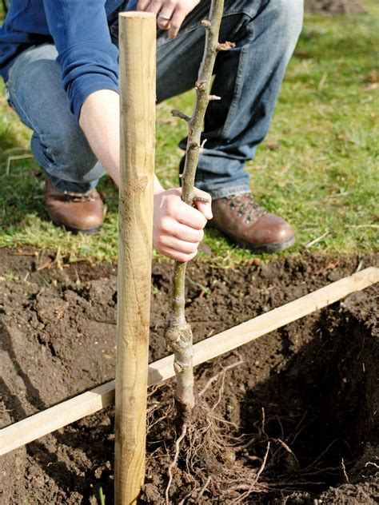
How to Plant a Bare Root Fruit Tree
- Dig the hole a little deeper than the root is tall — and make it wide enough to accommodate the longest roots without bending.
- Loosen the sides of the hole. Young roots may not readily penetrate a slick interface.
- Backfill with a 50% native & 50% Soil Booster until the bottom of the hole is at the right planting depth for the tree. If multi-planting in one hole, backfill to correct planting depth for each tree.
- Prune off any broken, rotted or twisted roots, making a clean cut.
- Position the tree, spread the roots and refill the hole, tamping the soil around the roots as you go.
- If planting in fast-draining soil, water thoroughly in order to finish settling the soil around the roots. In slower-draining soils, water a little at a time - over several days if necessary.
- Usually, no further water is necessary until there is new growth of several inches, but the soil must retain moisture.

Note: If there is a prevailing wind in your area that reaches your site, compensate by leaning the tree slightly into the upwind direction when you plant. The side of the tree where the scion emerges from the rootstock should be pointing upwind.
Ongoing Care
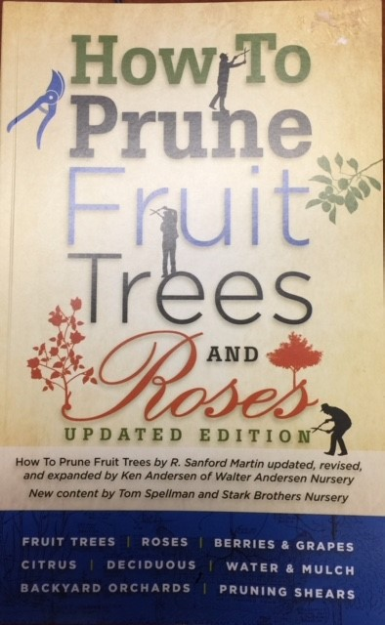
Pruning: If you want the fruiting wood to begin low, smaller trees may be cut back at planting time to a height as low as the knee (15-20 inches) is recommended. Any remaining side limbs should be cut back to one or two buds. Larger trees may be cut above existing well-placed low limbs, or they too may be cut back low to force new, lower limbs. How to Prune Fruit Trees & Roses is a must have resource and is a concise guide for the home orchardist.

Paint the Trunk: Sunburn can easily damage newly planted trees, especially in the climates of the southwest. We carry Go Natural Paint & IV Organic. IV Organic has essential oil to help fight insects & rodents. Paint your newly-planted trees from the ground all the way to the top.

Mulch: Mulch applied as a top dressing is beneficial to plants and the soil; as mulch decomposes it provides a steady source of nutrients to plants and organic matter to the soil. It also helps to stabilize and conserve soil moisture. *Make sure you are fertilizing, as decomposing wood can reduce nitrogen in the soil or even cause death.

Pest Control: For home fruit trees, the recommended approach to pest management starts with growing otherwise healthy, vigorous trees capable of resisting pest and disease pressures. Deciduous fruit tree health and vigor depend on good cultural practices with respect to variety and rootstock selection, planting, irrigation, fertilization, pruning, weed control and orchard sanitation. Strong-growing trees are generally much more tolerant of pests than weak ones.

Chemical pesticides are used only when absolutely necessary, based on a correct diagnosis and assessment of damage, and only in the safest, most limited way possible. Note: fruit trees do not have to be completely pest-free to be strong and healthy.

Trees growing in fertile, aerated (well-drained), consistently moist soil tend to have greater resistance to pests than trees stressed and weakened by too much or too little water. Do not over-fertilize. Too much nitrogen leads to excessive vegetative growth and increased disease susceptibility (as well as lower fruit production). Control weeds; they compete with trees for soil moisture and nutrients, in addition to providing habitat for pests.

Keep up with pruning for air circulation and sunlight penetration in the canopy. An open, airy canopy will dry much more quickly after rain or morning dew, minimizing the spread of disease. If possible, when planting choose sites that receive morning sun and are exposed to good air circulation.

If pest damage is observed and you are not familiar with the pest or symptoms, bring in a leaf, twig or fruit samples (sealed in a plastic bag) for diagnosis and recommended course of action. Insecticidal soaps, applied correctly, can be effective against aphids, mealybugs, spider mites, psyllids, scale, thrips, and whiteflies. Chemical pesticides are used only when necessary; the wrong treatment or timing does more harm than good if it harms a pest's enemies more than the pest. We recommend Bonide Orchard Fruit & Nut Spray for a safe & natural solution to manage pests and fungus during the growing season.

In fall, as soon as the leaves are off the trees, remove all leaves, twigs and fruit that might harbor pests, including any mummified fruit left in the trees. Hot composting of the debris (large pile, kept moist and well aerated) will kill most pathogens, but the usual recommendation is to discard.

Dormant Preparation: Dormant oil sprays can be essential for the control of many overwintering pests, such as scale, mites and aphids. Spray with Bonide Copper Fungicide & All Seasons Mineral Oil to control such diseases as peach leaf curl and shot hole fungus. During Dormant Season, fertilize with Sul-Po-Mag & Alfalfa Meal for better fruit and bloom production, & disease resistance.

Fertilizer: Fruit trees are heavy feeders. We recommend E.B. Stone Fruit & Citrus food. An organic source is preferred to avoid burning in higher heat. Scatter a ring of about 1/4 to 1/2 lb. of fertilizer around trees after they have at least 12 to 15 inches of new growth. Keep fertilizer at least 15-18 inches away from the trunk of the tree. We recommend a second and third application during the first summer.

